St. Francis Institute of Technology

(Engineering College)
An Autonomous Institute, Affiliated to University of Mumbai NAAC
A+ Accredited | CMPN, EXTC, INFT NBA Accredited | ISO 9001:2015 Certified
Department of Artificial Intelligence and Machine Learning
Academic Year: 2025-2026 Term: Even (Jan. 2026 – Jun. 2026) Class / Branch: SE – AIML Semester: IV
Course: Web Programming Lab. (AI4VS_LR4)
Date of Assignment: / /2026 Date of Submission: / /2026
___________________________________________________________________________________________ Pre-Lab Exercises for Experiment-5
DOM Basics & Preparation for To-Do List Application
Before performing Experiment-5, understand how JavaScript interacts with HTML elements using the DOM. These exercises help practice element selection, content update, and event handling, which are essential for building a To-Do List application.
Part A: DOM Fundamentals (Conceptual)
Exercise 1: Understanding DOM
Task:
• Define DOM.
Definition: The Document Object Model (DOM) is a programming interface for web documents. It represents the page so that programs can change the document structure, style, and content by treating the HTML as a tree of objects
• Draw a simple DOM tree for an HTML page with <html>, <body>, <h1>, and <p>.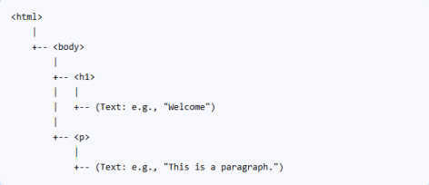
Exercise 2: DOM Selection Methods
Task: Write the purpose of:
• getElementById() :Returns a single element object whose id property matches the specified string. • querySelector() : Returns the first element within the document that matches the specified CSS selector. • querySelectorAll() : Returns a static NodeList representing a list of the document's elements that match the specified group of selectors.
Part B: Hands-On DOM Practice
Exercise 3: Accessing Elements
Task:
• Create a paragraph with an id.
• Use JavaScript to change its text using a button click.
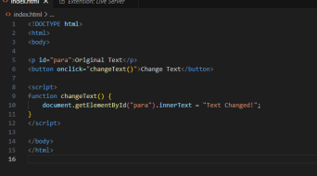
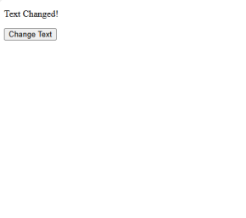
Exercise 4: Creating Elements Dynamically
Task:
• Create a button.
• When clicked, add a new paragraph to the page.
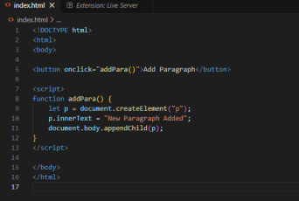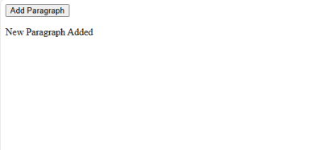
Exercise 5: Removing Elements
Task:
• Create a paragraph.
• Add a button to remove the paragraph using JavaScript.
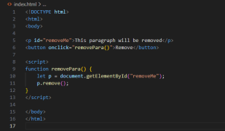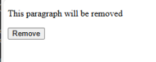
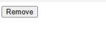
Part C: Event Handling Practice
Exercise 6: Event Listener
Task:
• Use addEventListener() to display a message when a button is clicked.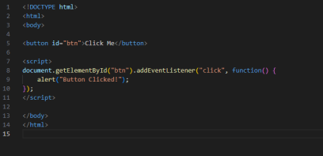
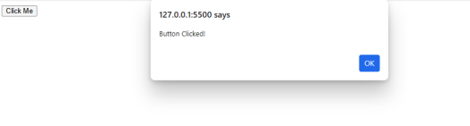
Exercise 7: Input Handling
Task:
• Create a text input.
• Display the entered text below the input when a button is clicked.
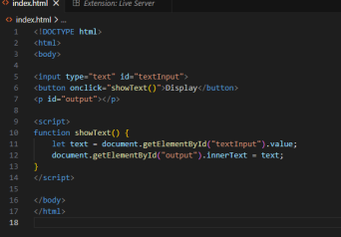
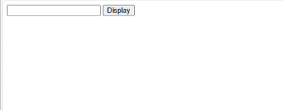
Part D: Logic Preparation for To-Do List
Exercise 8: Simple Task Addition Logic
Task:
• Enter text in an input box.
• On button click, display it as a list item.
